07. How to add a quick note to a resident’s profile
Adding a quick note to a resident’s profile in Nourish is used to highlight key information that is not available in the Critical Information, including information on slings/hoists, if they are unable to use a call bell and life-threatening allergies.
The quick note is visible to all users before they click into the resident’s profile
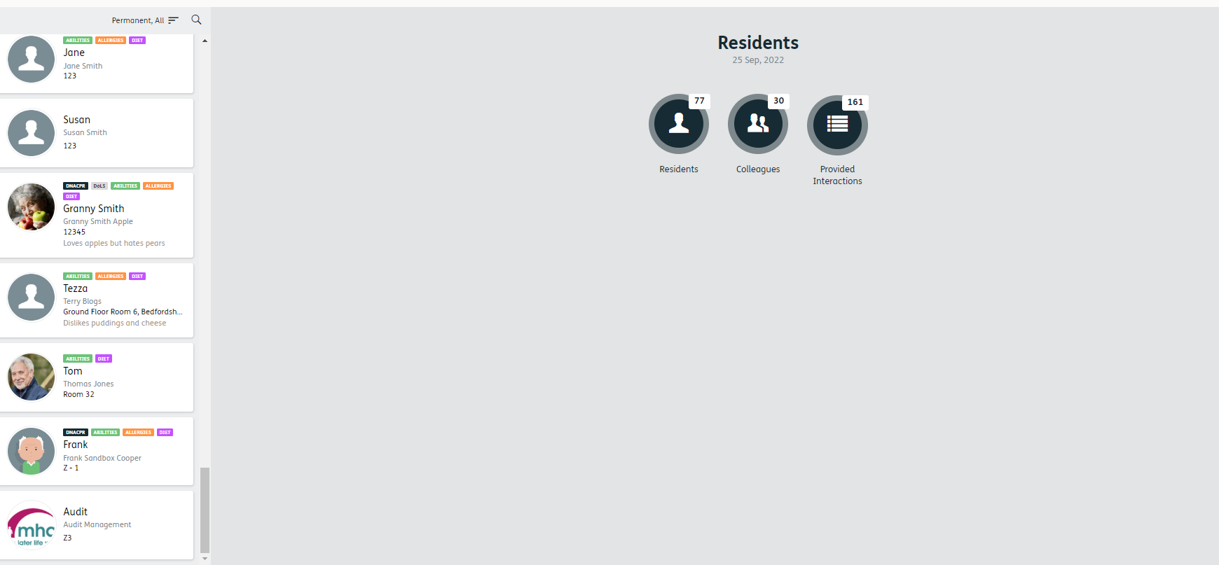
To add a quick note, please follow the below steps.
- Select the resident you would like to update

1

2
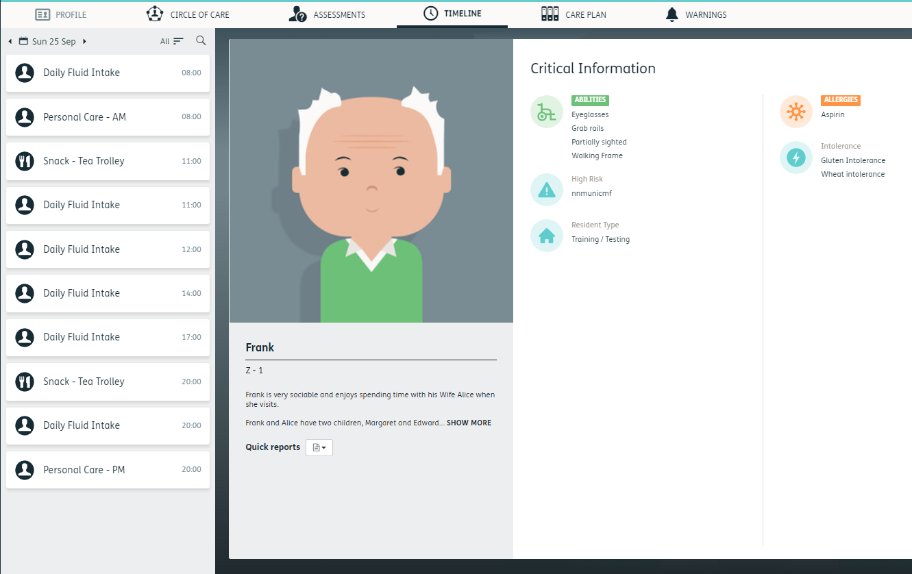
- Select ‘Profile’

- Select General Information
- Click ‘Update’

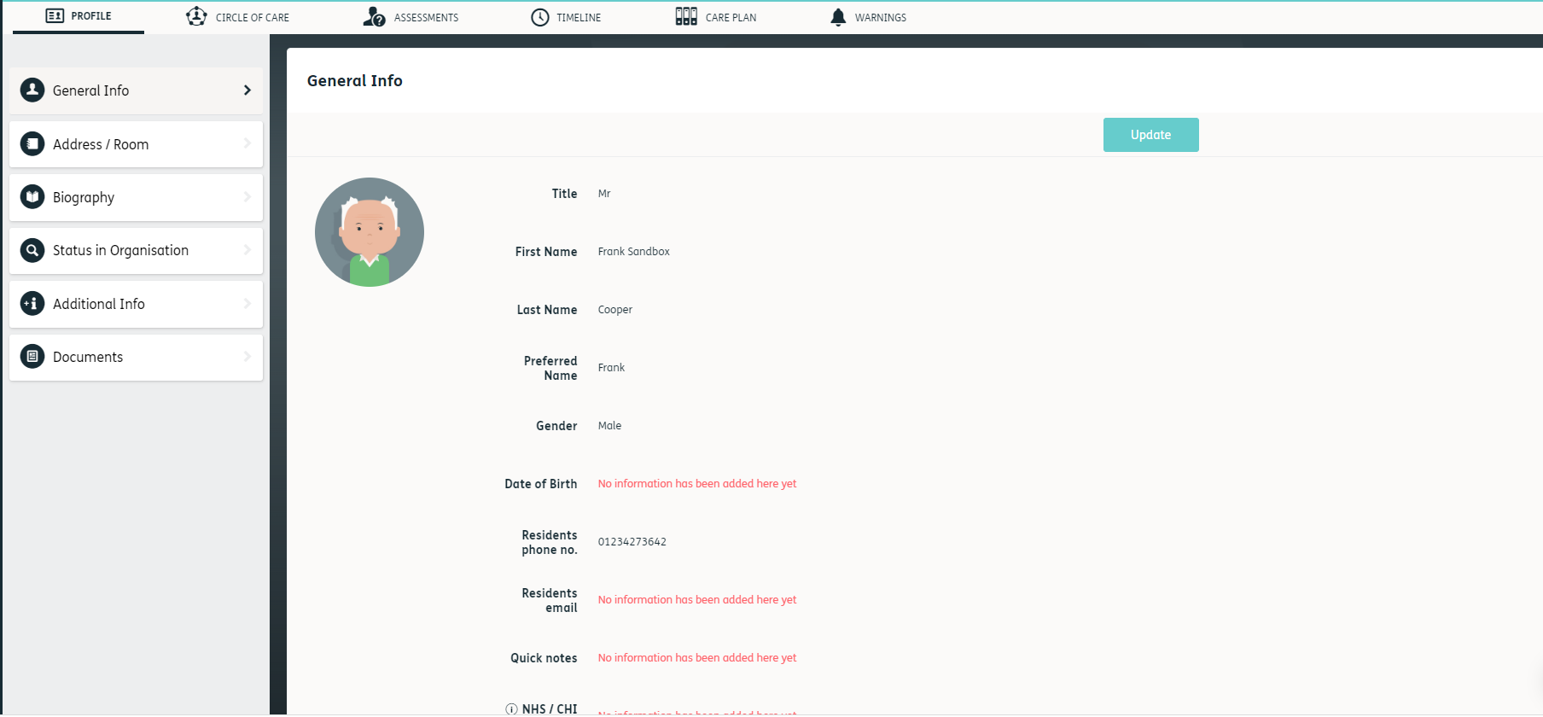
3
4

- Scroll to locate the ‘Quick Notes’ section
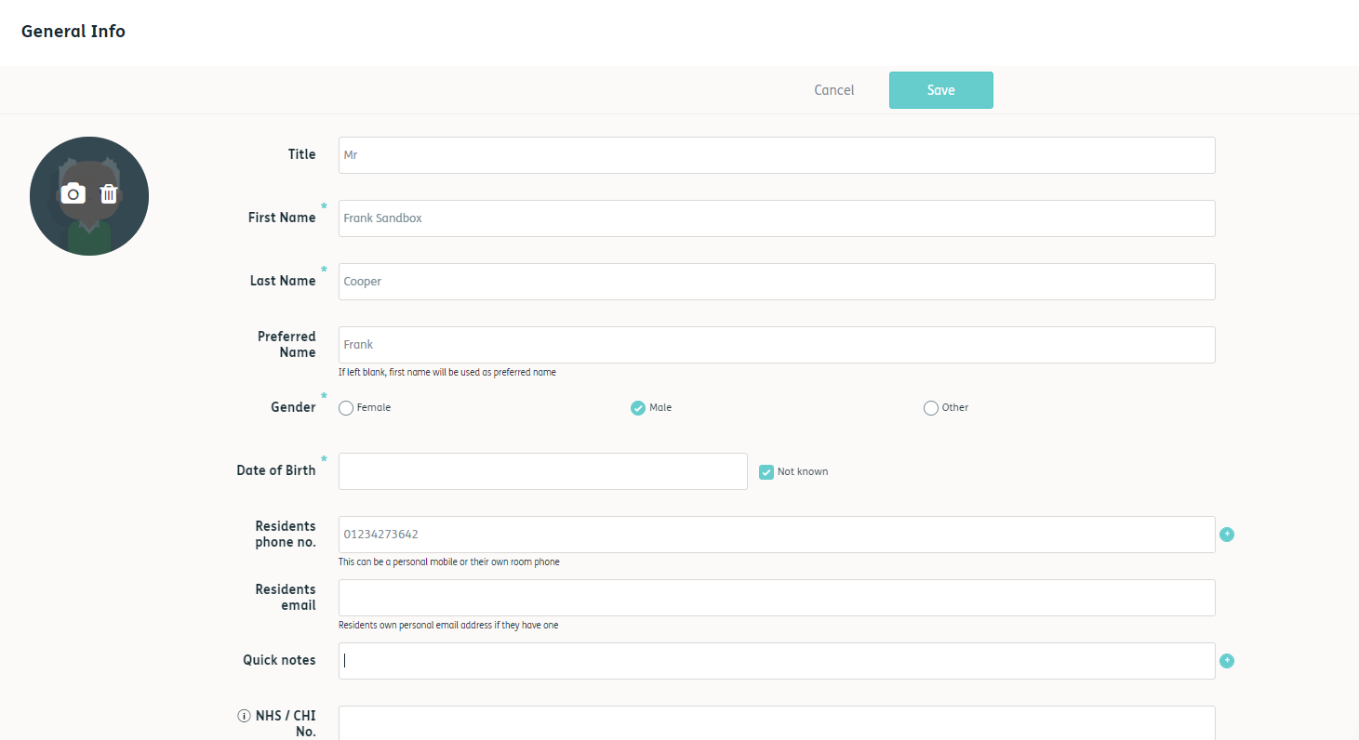

5

- Update with the information required
7
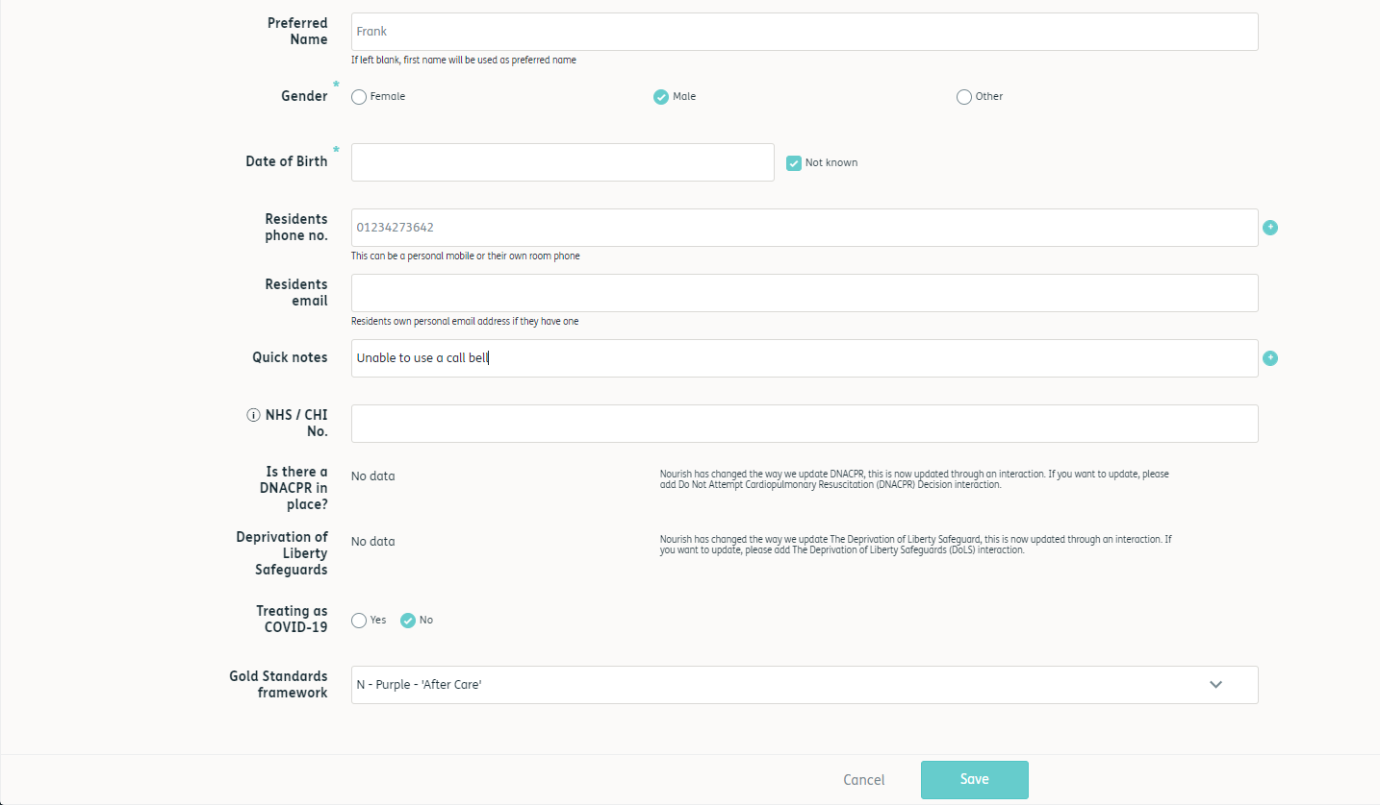
- Click ‘Save’
6
7

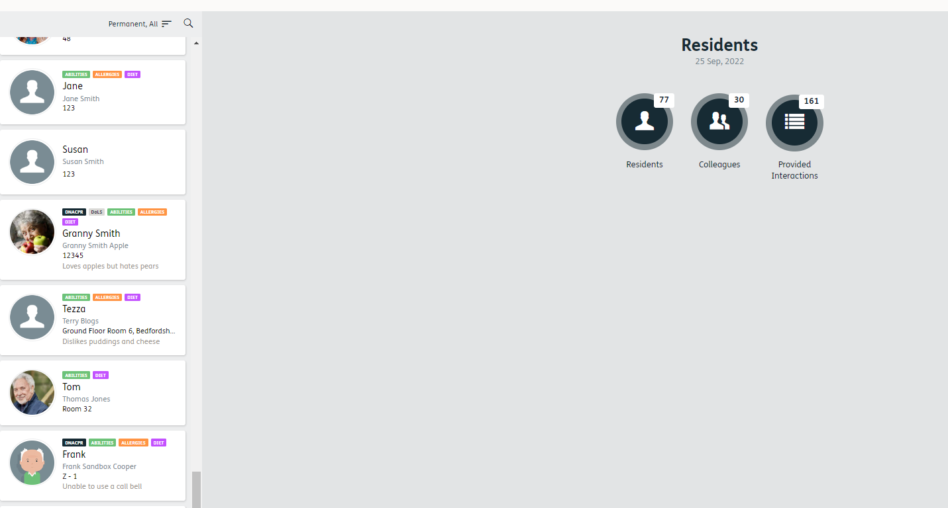
- Refresh the page and the quick note will be available on both the residents page, and the personal profile of the resident.
8

